**CLINICAL GRC APPLICATION**

The application allows the clinic to receive/enter patient applications more effectively and update the GRC and notify researchers. This will reduce redundant applications from frequent applicants/applications and increase approval speed from researchers by allowing them to see and review more applications more efficiently. The main dashboard will keep track of all applications and their status sent on the account. The application itself will reduce repetitive data entry for past patients and new patient records will be automatically created.

1. Login Authentication screen with username and password, same as computer log in (~ 1-2 days)
   1. Each user is different, depending on the role and application will have different uses for each user. (admin/support/team member)
2. Main dashboard screen with different statistics/metrics depending on user, design similar to current GRC dashboard (~ 2-3 days)

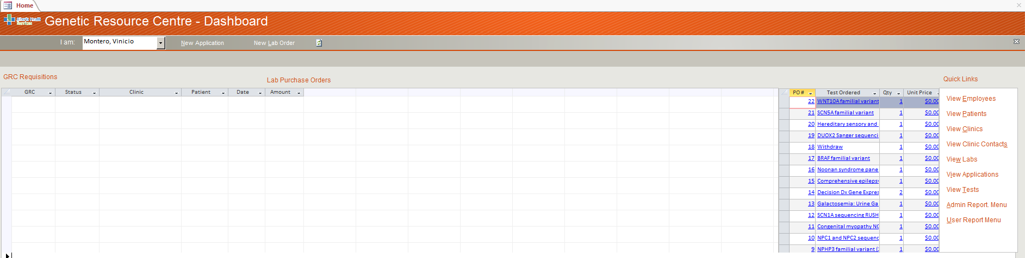

* 1. Ability to create new or edit pending GRC applications
  2. Application has access to **GRC Database**
  3. Ability to search applications, patients, and tests.
  4. Shows number of applications and their status (approved, sent, withdrawn, open, pending submission) in tables.
  5. Other metrics for admin users, including applications sent per user, details, and summary.

1. When creating a new GRC application, it has a design similar to the current GRC (~ 2-3 days)
   1. Similar entry fields as paper application
   2. Able to perform patient search; if it is a new patient, submitting application will create new patient and GRC number in database. If patient already exists, select existing patient in database. This allows the application to show past tests results, labs and diagnosis in drop downs.
      1. Search by **First/Last name, Personal health number**, and Date of birth.
   3. Able to attach PDFs to application
   4. Able to save an ongoing application to the dashboard and resume other pending applications.
2. Application form gives test requested and will search by drop down.
   1. Certain labs have certain tests, certain tests are at certain labs.
   2. If there is no current test matching the test requested, researchers would be notified by email to add the new test in the database and there would be an “Other:” entry box for the new test request.
   3. Once test is selected, it will show if it is PTLL or not.
   4. Non – PTLL tests would require more information (family history, risks, other testing, and additional details)
3. Once the application is complete and submitted, GRC database and dashboard would be automatically updated, and the genetic researchers and physicians would be notified if the application is urgent or if there is a new test. (~ 1 days)
   1. Once the submit button is selected, there is no going back and there will be a new GRC number generated with the patient information and application.
   2. Applications would appear in order by the received date and its urgency
   3. Notification by email (only if urgent and new test request)
4. ***When the report is available after the test, it would be updated in the database and can be accessed by clinical genetics.***
   1. Create result button beside the new application button